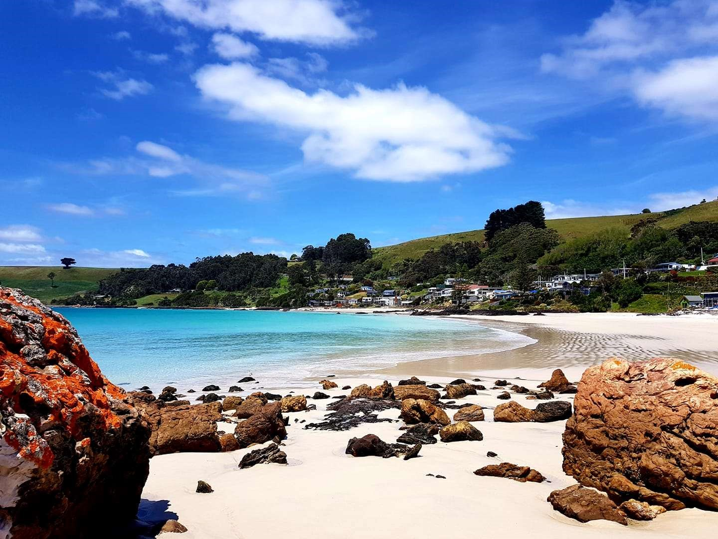
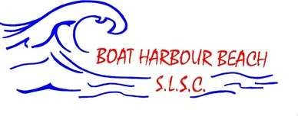

Patrol Operations Manual

20
21
-
202
2

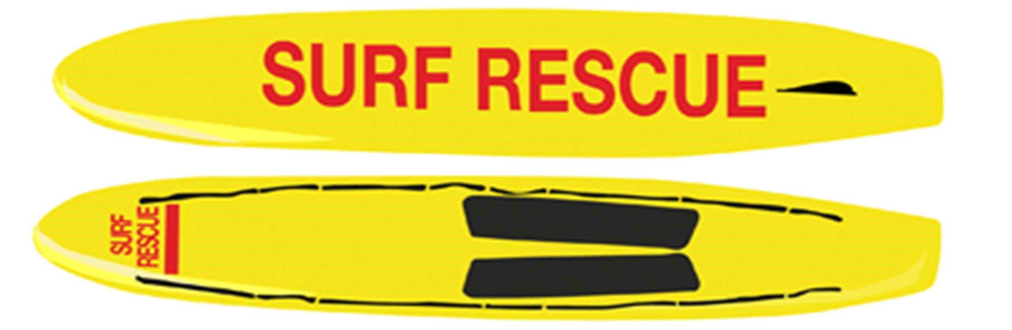

To the Boat Harbour Beach Patrolling Members,

I would like to thank you for volunteering your time to another season at our little Surf Club and continuing the service of saving lives and protecting our community.

This document is known as the Patrol Operations Manual (POM). It is reviewed annually and if you have any feedback or suggestions they are always encouraged.

The POM contains information on how to patrol effectively at our beach as well as our common hazards accompanied with risk management plans.

I recommend all Patrol Captains and new patrol members and encourage any other patrolling members to read through this manual and familiarise yourself with the Operations at Boat Harbour Beach.

If this manual is unable to answer your questions, please refer to the Surf Life Saving Tasmania Standard Operating Procedures (2015), found online or in the Patrol Room.

I am excited to see you all on the beach, if you have any questions, please don’t hesitate to contact me.

Regards,
Suzanne Fairbrother
BHBSLSC Lifesaving Manager
Contents

1 Communication
1.1 State and Emergency Services Contacts
1.2 Club Contacts
1.3 Boat Harbour Beach SLSC Emergency Response Callout Team
1.4 Tasmanian Radio Network

2 Hazard and Risk Management
2.1 Geographical Area Map
2.2 Local Hazards/Risks Map
2.3 Risk Management Plan

3 Beach Management
3.1 Minimum Patrol Requirements
3.2 Patrol Types
3.3 Daily Patrol Procedures
3.4 New Patrol Member Induction
3.5 Nippers/Water Safety
3.6 Local Government By-Laws
3.7 2021-2022 Lifesaving Service Agreement, Patrol Roster and Contact List

4 Emergency Operations Plan
4.1 Emergency Rally Point/Helicopter Landing Zone
4.2 Emergency Beach Closure
4.3 Tsunami and Flood Plan
4.4 Bushfire Plan

1 COMMUNICATION
1.1 State and Emergency Services Contacts
Surf Lifesaving Communications
Service | Phone | Email
Surf Life Saving Tasmania (Hobart) | (03) 6216 7800 | slst@slst.asn.au
Emergency Services  - Ambulance  - Police  - Fire Department | 000 or 112 (International) | N/A
State Duty Officer | 13 SURF (13 7873) | N/A
Wynyard Police Station | 6477 7267 | N/A
Wynyard Volunteer Marine Rescue | Through 13 SURF | N/A
Poisons Information | 13 1126 | N/A
Waratah-Wynyard Council | (03) 6443 8333 | council@warwyn.tas.gov.au
Tasmania Parks and Wildlife Service | 1300 TASPARKS (1300 827 727) | N/A
Services that need to be coordinated for an incident should be requested through the State Duty Officer (13 SURF). If emergency services are needed, contact 000 directly. Contact the State Duty Officer (13 SURF) after an incident to coordinate counselling services.

1.2 Club Contacts
Club Position | Name | Mobile Number | Email
President and Board Chairman | Paul Willmot | 0427268045 | paul.bhbslsc@gmail.com
Board Director | Graeme Fairbrother | 0417524140 | info@fairbrothersbodyworks.com.au
Board Director | Sarah Willmot | 0477043765 | bhbsarah@gmail.com
Board Director | Margot Ellis | 0417013001 | margotjeannekelly@gmail.com
Board Director | Angus Cheek | 0457124268 | anguscheek@gmail.com
Safety Officer | Gavin Coward | 0408576010 | gcoward@haywards-steel.com
Lifesaving Manager | Suzanne Fairbrother | 0407901943 | sfairbrother@bigpond.com
IRB Officer | Darcy Gregson | 0477703334 | darcgrego@gmail.com
Gear and Equipment Officer | Mani Gregson | 0499925520 | mani.gregs@gmail.com
Radio Officer | Angus Cheek | 0457124268 | anguscheek@gmail.com
First Aid Officer | Sarah Willmot | 0477043765 | bhbsarah@gmail.com
Education and Training Manager | Abigail Avery | 0409951394 | abby03023@gmail.com
Surf Sports Manager (Nippers) | Cameron Taylor | 0477703334 | ctaylor@atraccountants.com.au
Registrar | Vanessa Fairbrother | 0437352420 | vanessa.fairbrother@bigpond.com
Accounts | Margot Ellis | 0417013001 | margotjeannekelly@gmail.com
Club House Manager | Paul Willmot | 0427268045 | paul.bhbslsc@gmail.com
Club Gym Manager | Stephen Gardiner | 0419314499 | sand_s@internode.on.net
Patrol Captain | Abigail Avery | 0409951394 | abby03023@gmail.com
Patrol Captain | Felix Ellis | 0457517734 | felixaellis@gmail.com
Patrol Captain | Abbey Fairbrother | 0467658841 | abbey.fairbrother98@gmail.com
Patrol Captain | Bailey Fairbrother | 0498628814 | bailey.fairbrother@gmail.com
Patrol Captain | Graeme Fairbrother | 0417524140 | info@fairbrothersbodyworks.com.au
Patrol Captain | Suzanne Fairbrother | 0407901943 | sfairbrother@bigpond.com
Patrol Captain | Mani Gregson | 0499925520 | mani.gregs@gmail.com
Patrol Captain | Carolyn Hay | 0438451229 | carolyn.hay@education.tas.gov.au
Patrol Captain | Paul Willmot | 0427268045 | paul.bhbslsc@gmail.com
Patrol Captain | Sarah Willmot | 0477043765 | bhbsarah@gmail.com

Club House Phone Number: N/A
Club House Address: 288-290 Port Road, Boat Harbour Beach, TAS, 7321
Club Mailing Address: PO Box 630, Wynyard, TAS, 7325
Club Email Address: boatharbour@slst.asn.au
Club Website: boatharbourbeachslsc.asn.au

1.3 Boat Harbour Beach SLSC Emergency Response Callout Team

Name | Club Key | IRB Driver | Availability | Mobile Number | Other Number
Abbey Fairbrother | Yes | Yes | 24/7 | 0467658841 | 64451152
Bailey Fairbrother | Yes | Yes | 24/7 | 0498628814 | 64451152
Graeme Fairbrother | Yes | Yes | 24/7 | 0417524140 | 64451152
Darcy Gregson | Yes | Yes | 24/7 | 0477703334
Paul Willmot | Yes | Yes | 24/7 | 0427268045

As part of our Lifesaving Agreement with Surf Life Saving Tasmania, we are required to provide Emergency Response. Surf Life Saving Tasmania’s Regional Emergency Response Teams provide an after-hours callout service to compliment and support emergency services through advanced aquatic skills and use of specialised first aid and rescue equipment during times of need. Advanced skills and training are offered with regional search and rescue exercises for the team. The above people are members of our Surf Club that I would like to thank for providing an additional service for our club to benefit our community and their safety, particularly in the aquatic environment. We are the most Western Emergency Response Team, meaning we are likely to be activated and therefore need to be rescue ready out of patrol hours and during the off season. Although, we are able to reject a request if our team believes it creates a level of unacceptable risk.
When Emergency Services require our help, they contact the State Duty Officer from Surf Life Saving Tasmania (13 SURF), they will then contact one of the members of our Emergency Response Team.
The State Duty Officer will coordinate the entire response to an incident with the Emergency Service, as well as communicating further services (e.g. Marine Rescue). Our response team will get together to organise equipment and plan how to respond to the incident.
Equipment Required to be Rescue Ready:
- 2x rescue tubes with swimming fins
- 2x rescue boards
- 1x IRB with full fuel cell, deployment kit, 2x radios with aqua pouches, and ATV • 1x ART kit, first aid kit, and AED

1.5 Tasmanian Radio Network
Channels | Use
32A | ‘Line of site’ used on patrol within our Surf Club
16 | Volunteer Marine Rescue
Boat Harbour | Table Cape Repeater to allow State Surf Club communication
SurfComms | Future development (not in use yet) for radio communication to the State Duty Officer (currently 13 SURF)

2.3 Risk Management Plan
Hazard | Risk | Management Plan
Occasional Rips/Current | There are two rips/currents that can occur at our beach, pre-determined by the weather conditions. They are commonly located along the rocks at either end of our patrolled area. They are not very strong.  Consequence: Drowning  Likelihood of Hazard: Likely  Likelihood of Consequence: Unlikelypossible | - Monitor rips from base and patrol  - Have flags demarking safe areas  - Encourage swimmers to swim between the flags  - Have minimum 2 lifesavers between flags when people are in the water  Equipment: Flags, radio, IRB, rescue tube and fins  Response: Use IRB for rescue, with crew using tube near rocks
Low Water Temperature | All year round the temperature of our water is very low and accompanied with the wind that is commonly present, people at our beach can get very cold very quickly.  Consequence: Low body temperature hypothermia  Likelihood of Hazard: Almost Certain  Likelihood of Consequence: Likely | - Monitor the beach for people who appear cold  - Member knowledge on the identification and treatment of temperature related illness’  Equipment: Shelter from wind, emergency blanket  Response: Remove patient from environment (either side of the playground depending on wind direction is the best spot) and remove wet clothes, wrap in towel/blanket/emergency blanket, give warm sweet drinks, call 000 if hypothermia
High UV Rating | In Tasmania there is a hole in the ozone layer above us, predisposing our community to higher UV levels than the rest of the country.  Consequence: Sunburn  Likelihood of Hazard: Almost certain Likelihood of Consequence: Almost certain | - Represent sun safety with correct patrol uniform  - Walk around the community offering sunscreen  - Leave sunscreen within patrol area for public use • Advise UV rating on Patrol Notice Board  Equipment: Sunscreen, ‘Soov’ after sun care, cool running water Response: For minor sunburn provide ‘Soov’ after sun care spray, for anything more severe use cool running water for at least 20 minutes and refer to medical advice if necessary
Submerged and Exposed  Rocks | We are surrounded by rocky bays and there are common areas within the ocean that contain submerged rocks. Consequence: Bleeding or spinal injury  Likelihood of Hazard: Almost certain Likelihood of Consequence: Possiblelikely | - Place flags to avoid submerged rocks  - Monitor people climbing on rocks (use binoculars if far)  - Maintain member knowledge on spinal treatment  Equipment: Binoculars, first aid kit, spinal board and straps Response: Treat any bleeding with saline and appropriate dressings, use spinal board to stabilise patient and call 000
Rough Surf | In a strong Easterly wind direction, we commonly get larger surf than can become rough.  Consequence: Drowning, spinal injury  Likelihood of Hazard: Possible Likelihood of Consequence: Unlikelypossible | - Close beach if surf becomes too dangerous  - Use highly competent and confident lifesavers for rescue  - Discuss what will be the safest rescue equipment  - Maintain member knowledge on spinal treatment  Equipment: Rescue equipment, spinal board and straps  Response: Rescue patient if possible and safe, if not call 13 SURF to coordinate rescue, treat spinal case/drowning and call 000
Scuba Divers and  Snorkellers, Common Surf | At the West edge of the beach there are rocks and sea life that is commonly examined by snorkellers and scuba divers. It can be hard to watch these | • All public members are informed about zones and appropriate speeds to minimise conflict between the members

Zones, and Powercraft  Access and Operation  Areas | people. At the East edge of the beach the swell is typically better making this area (outside of the patrol area) attractive to surfers. On nicer weather days we commonly get jet ski’s and boats at the beach.  Consequence: Unidentified incident and conflict  Likelihood of Hazard: Likely  Likelihood of Consequence: Unlikelypossible | - Make sure scuba divers have appropriate buoy  - Encourage a buddy system  - Perform roving patrol if surfing zone is high risk  (environmental and human)  Equipment: Rescue and patrol equipment  Response: Have two vigilant members at the water’s edge at all times with appropriate rotations, identify zones and scan them, use IRB or rescue board to contact public members in water if increasing risk of injury
Fuel and Powercraft  Storage | Our IRB shed is situated in the car park behind the Surf Club where we store our 2 IRB’s, 3 motors, ATV, fuel, and an air compressor  Consequence: Fuel: flame/explosion, contamination from fumes, ingestion or contact. Equipment: lifting injury due to heavy weight, injury due to misuse or failure, tripping from things left on floor.  Likelihood of Hazard: Almost certain  Likelihood of Consequence: Possible | - Appropriate signage on shed  - Fuel, oil and lubricants kept in approved locker  - Only qualified and inducted members use equipment  - Follow correct lifting procedures  - Keep shed clean and organised  Equipment: Fire extinguisher/blankets, hazard signs, running cold water, dressings  Response: Call 000 and attempt to extinguish fire, treat people for burns, treat people if contaminated by calling Poisons  Information (13 1126), treat any injury caused by improper lifting or tripping (e.g. sprains, strains, breaks, bleeding etc.)
Oxygen Bottle Storage | In our patrol/first aid room we have 2 oxygen resuscitation kits (yellow bags) that each contain oxygen bottles, with spare unopened oxygen bottles kept in the operations cupboard  Consequence: Explosion or injury  Likelihood of Hazard: Almost certain Likelihood of Consequence: Rareunlikely | - Only ARTC qualified members handle the oxygen bottles  - Keep regulator on opened bottles unless being cleaned  - Do not handle bottles in presence of naked flame or oils  - Avoid rough movement and heat to the bottle  - Do not ‘crack’ new bottles  - Do not put yourself opposite to the yoke of the bottle Equipment: Fire extinguisher, first aid kit  Response: Call 000 and attempt to extinguish fire, treat any injuries that have resulted from the oxygen bottle exploding or moving uncontrollably.
Playground | There are two playgrounds at the beach. One is situated in front of the Surf Club, with the other across the street. These playgrounds is a Council responsibility, we may need to provide first aid treatment if the consequence occurs.  Consequence: Injury on equipment or whilst crossing the street  Likelihood of Hazard: Almost certain Likelihood of Consequence: Possiblelikely | - Make sure younger children are supervised  - Contact council about re-design of hazardous parts (these playgrounds will be removed in the next 2-3 years due to the new re-construction of Boat Harbour)  Equipment: First aid kit  Response: Treat any injuries that present appropriately
Marine Stingers | We get marine stingers (blubber jellyfish, sea lice and blue bottles) about 2-3 times a year. They typically | - Note on patrol notice board when they are present  - Place marine stinger sign next to patrol flag (do not currently have one)
 | come with the warm currents in January.  Consequence: Sting  Likelihood of Hazard: Possible Likelihood of Consequence: Likelyalmost certain | - Member knowledge about the type of marine stingers and their treatments at our beach  - If allergic reaction occurs, gather history, call 000 and treat with personal EpiPen if anaphylactic  Equipment: Hot water, tweezers and gloves  Response: Treat sting with running hot water for approximately 10 minutes, pick off any remaining tentacles while wearing gloves

3 Beach Management

3.1 Minimum Patrol Requirements

Lifesaving Personnel/Qualifications
All club patrols shall at a minimum have on duty the following personnel with the following qualifications, for the duration of the base patrol.
Minimum number of 4 made up as per below:
- 1x Silver Medallion Basic Beach Management (Patrol Captain)
- 1x Silver Medallion Inflatable Rescue Driver*
- 1x Inflatable Rescue Crewman*
- 1x Advanced Resuscitation Techniques
- 3x Bronze Medallion
*Note: These awards may not be filled by the same patrolling member

Lifesaving Equipment
A Surf Life Saving Club on duty should have the listed equipment below as a minimum:
- Red and Yellow Feathered Patrol Flags
- IRB with trailer
- 2x Handheld radios
- Patrol Information Board
- Rescue Craft Access Signs
- ATV/vehicle
- Tower or shade (tent)
- 1x pair of binoculars
- 1x Rescue Board
- 1x Rescue Tube with Swimming Fins
- 1x Automated External Defibrillator
- 1x Oxygen Resuscitation Kit
- 1x First Aid Kit
- 1x set of spinal equipment

3.2 Patrol Types

Base Patrol
A Base Patrol is always the core patrolled area for a lifesaving service established and dates as identified in the Lifesaving Service Agreement. A Base Patrol must meet all minimums for personnel and equipment as stated below to be considered ‘beach open’.

Roving Patrol
This is known as a type of Sub Patrol, which supports the base patrol. There are several other types of sub patrols, however, this is the only other sub patrol we conduct at our beach. We tend to do roving patrols to the other end of the beach when there are many people down there, which is usually when there is good surf. We either have 2 members of the team walk with a radio, first aid kit and rescue tube with fins, or 2 members in the ATV with a radio, first aid kit, oxygen resuscitation kit and rescue tube with fins.

Closed Patrol
In the interest of public or member safety, the beach may be deemed unsafe and closed by the Patrol Captain. All minimum personnel and equipment must be maintained, with the exception of the patrol flags which must be laid in a cross, and danger signs must be placed. You do not have the authority to prohibit people from entering the water, only to advise them of the risk. If the point is reached where it is no longer safe to perform rescues and one must be performed, contact 13 SURF to coordinate.

3.3 Daily Patrol Procedures

Start of Patrol
- All members arrive at least 30 minutes prior to start of patrol
- Minimum standards assessed (numbers, qualifications, gear)
- Equipment checked and positioned for patrol
- Flagged area established
- Patrol log completed through the Operations App on the iPad
- ‘Patrol Briefing’ conducted by Patrol Captain

During Patrol
- Always maintain safety procedures
- Listen to the instructions from your Patrol Captain
- A minimum of 2 patrolling members between the flags when there are people in the water, try to rotate these members every 20-30 minutes

End of Patrol
- Patrol of the beach maintained by at least one lifesaver during ‘pack-up’
- Rescue equipment to remain at ‘rescue ready’ status during ‘pack up’
- Log books completed
- Patrol signed off through the Operations App
- All equipment cleaned and stored appropriately
- Radio’s placed on charge
- Any supply requirements or equipment damage reported to relevant club officer
- ‘Patrol Debrief’ conducted by Patrol Captain

3.4 New Patrol Member Induction
- Introduce the new patrol member to all members of the team
- Take them on a tour of the patrol room including what equipment we have, where it is stored (both during and out of patrol hours), and the relevant club officers to contact if replacement/maintenance is required.
- Take them on a tour of the Surf Club if they are a completely new member
- Contact the Operations Manager if they have not been given a patrol uniform
- Explain the patrol types we use and our common set-up and pack-down procedures
- Examine the common hazards at our beach
- Make sure they are always with a buddy on their first patrol
- If they are eligible and wish to drive the ATV, they must undertake an induction with the IRB Officer

3.5 Nippers/Water Safety
During the Summer, our Surf Club runs a Junior Activities and Member Training and throughout the season we also host Surf Sport Competitions (e.g. State Carnival or Ocean Swim) and Sanctioned/Special Events (e.g. School Picnics or Kirk Dicker Challenge) which require State or Council endorsement. All these programs require water safety for the ability to run a safe event.
Water Safety Procedure
There are two procedures to follow in terms of numbers for water safety; whether the participants have Surf Lifesaving Qualifications (Surf Rescue Certificate or above) or not. If participants have these awards, a buddy procedure is followed. If they do not, it is a 1:5 ratio (WSP:participants), allowing a 1:10 ratio in a low risk environment (general rule of thumb is swell <1m, however, always take other factors into account). An IRB is highly recommended to be used, with the 2 qualified members taking numbers from the ratio.

3.6 Local Government By-Laws
Consumption of Alcohol
Due to the café and bar at the beach, there is a licensed and non-licensed area at the beach. The licensed area is within the surf club building and the concrete ‘veranda’. This area is strictly where the consumption of alcohol must be purchased from the café, no BYO. All other areas at the beach BYO is allowed, however, any alcohol bought from the café is required to be consumed within the licensed area. If people outside of the licensed area are being irresponsible due to the consumption of alcohol, we can advise them against entering the water and moving other members of the public away. If any authority is required or risk will be posed on the patrolling members, call the local police or 000 if necessary.
Camping
The public reserves at Boat Harbour are day-use areas only. Overnight freedom camping is banned on all public reserves.
Dogs
Our beach from the Western end to the last house on the Eastern end is always restricted (on leash), and prohibited during Summer between 10am and 6pm according to the Dog Control Act 2000.

4 Emergency Operations Plan

4.1 Emergency Rally Point/Helicopter Landing Zone
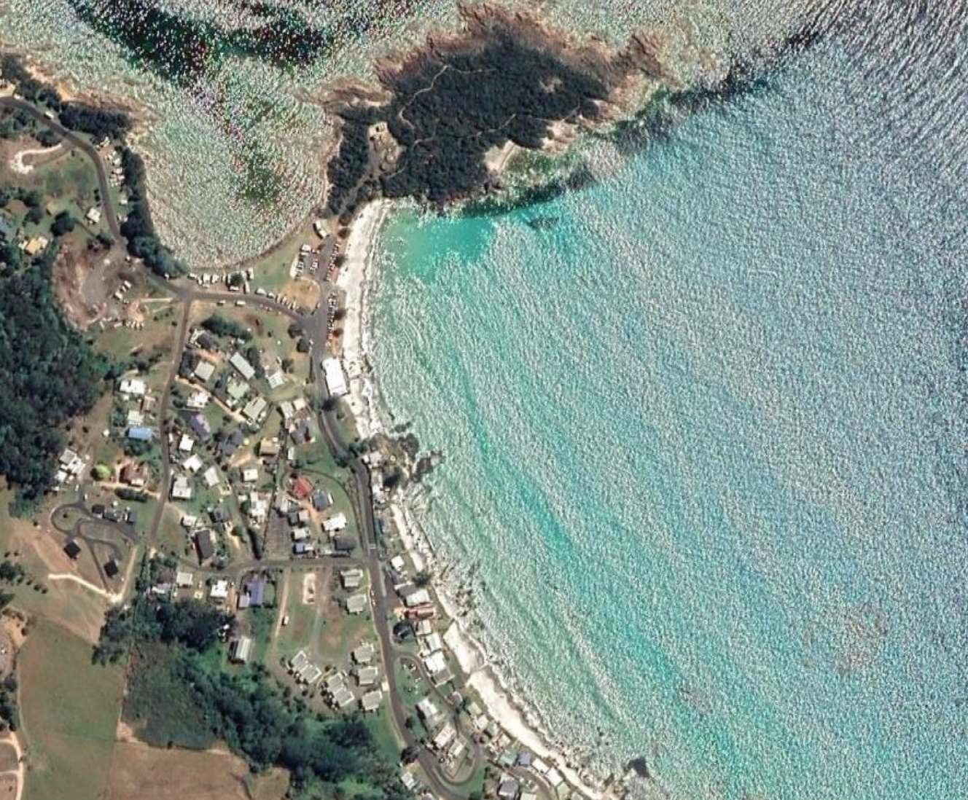

For any emergency call or evacuation, escort members of the public to the emergency rally point.

4.2 Emergency Beach Closure
During patrol, every member (especially the patrol captain) is consistently assessing the conditions of the beach. If there is an unacceptable/unmanageable risk to the public of lifesaving service, the beach can be closed.
Conditions may include but are not exclusive to:
Dangerous surf conditions (rips, dumping surf), marine life (sharks, excessive stingers), human hazard (uncontrollable craft), civil disturbance, equipment in swimming area (lines, netting), environmental (tsunami, cyclone, lightning), chemical/biological hazard.
For an emergency beach closure follow this procedure:
- Determine if the water needs to be evacuated
- Call 13 SURF to close the beach
- Activate the emergency evacuation alarm
- Inform all members of the public about the closure and reason
- Remove flags and post ‘Swimming Not Advised’ signs
- Continually monitor all areas and maintain minimum lifesaving standards
- Make appropriate record in the Operations App
Please note that you are not an authority, you cannot make people get out of the water, but only advise of the risk. Only re-open the beach when it is determined as safe.

4.3 Tsunami and Flood Plan
Due to our position within the Bass Strait and our proximity to tectonic plates, it is incredibly unlikely to have a tsunami at our beach. Floods although unlikely, they have a greater chance of occurring in comparison to a tsunami. In both of these emergency situations always get to higher ground. If you have more times, try to get to the top of Port Road towards Wynyard. If you have limited time, take Moore Street, Cummings Street or weave through the houses to get to the top of the hill, if required go through the paddock to get on top of the highest hill.
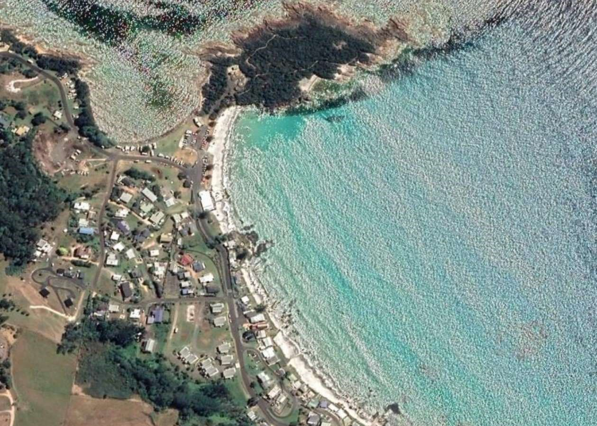

4.4
Bushfire Plan
Bushfires unfortunately do occur in Tasmania and on a few occasions have come very close to our beach, where the next town over was evacuated and we were on high alert. If we receive an evacuation warning, please follow it. If a warning was not given, and if there is time take Port Road and travel into Wynyard. If there is no time, run down to the beach and get into the water.

